Exercise #01
Android Developer Bootcamp

Purpose
This Exercise defines a simple ui that have a card, inside the card have a EditText, TextView and Button. If the User gives a text in a EditText and it will shown in the TextView.

Problem
This Exercise creates a card, inside the card have a EditText, TextView and Button.Also there is a data paasing.

How to Solve
1. Checkout the workshop from Git Repo:
git clone -b <user-branch> <repo-URL>
2. Open the root folder inside Android Studio.
3. To build the app click the run icon.
4. Create a a EditText, TextView and Button.
5. Developer can choose it’s UI design.

Screenshots

Expected Output

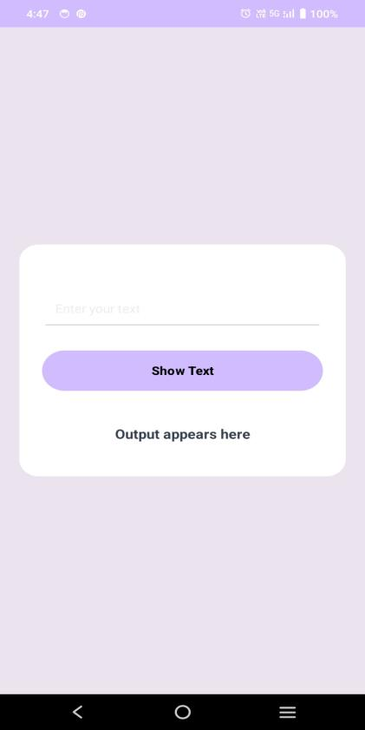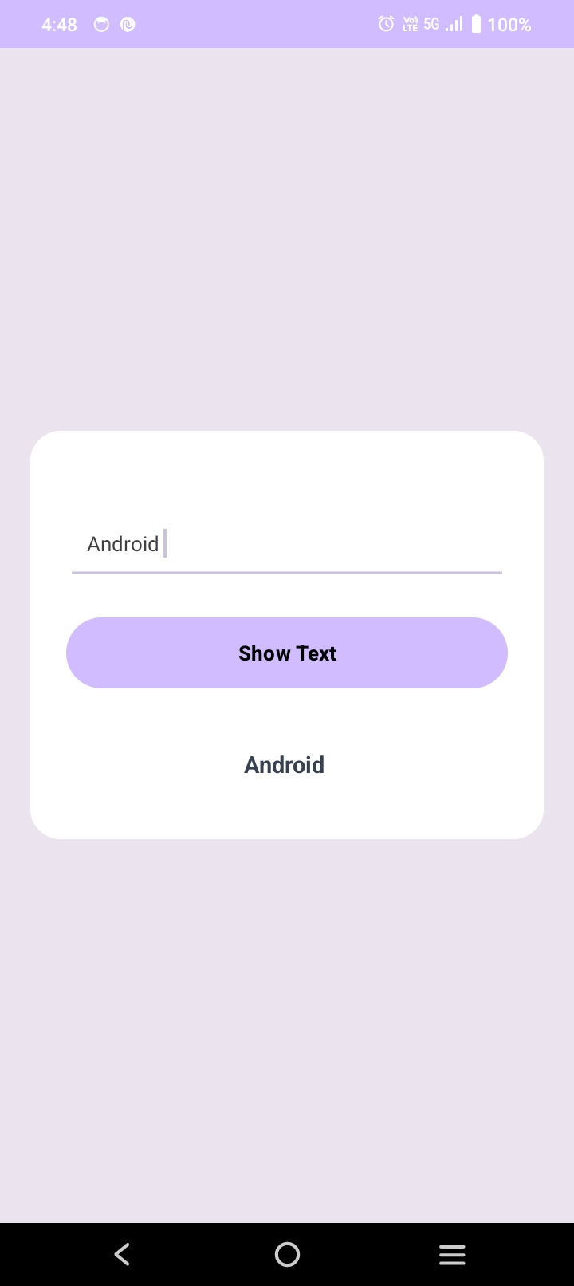

How to submit your Exercise
Push your project back to the same git branch using command:
<command name>

Happy Coding!

